**Snakes and Ladders**

Snakes and Ladders is an ancient Indian board game. It is played with two or more players on a square gameboard having a number of "ladders" and "snakes", each connecting two specific board locations.

The object of the game is to navigate one's game piece, according to dice rolls, from start to finish. If you reach a cell at the bottom of a ladder, you climb up that ladder; if you land on a cell that is the mouth of the snake, you must go down to the tail of snake without a dice throw. A commercial version with different morality lessons, Chutes and Ladders, is published by Milton Bradley. *(parts curtesy Wikipedia)*

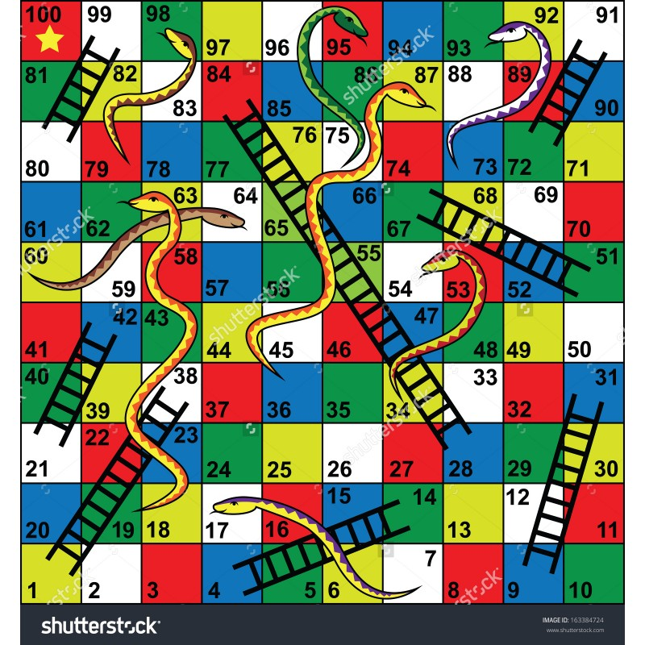

**Find the minimum number of throws (dice rolls) required to win a given Snake and Ladder game.**

The game board will always be a 10 x 10 grid; the snakes and ladders on the board are represented in the file "snakes.txt" as pairs of integers as follows:

* A single integer L, the number of ladders on the board, followed by L pairs of integers representing the start/end of the ladder.
* A single integer S, the number of snakes on the board, followed by S pairs of integers representing the head/tail of the snake.

The minimum number of dice rolls to win the game in the "snakes.txt" file is 7.